**HS-111 Servo 🡪 Product Description**

The HS-311 sport servo provides the novice modeler all the performance and reliability you would expect to find in a more expensive servo. Combined with precise resin gears and SMT circuitry, the HS-311 represents a remarkable value in today's R/C market.

**Features**

* Our Low Cost Standard Size Servo
* Reliable Three-Pole Ferrite Motor
* Durable Resin Gears
* Popular Selling Servo

**Specifications**

|  |  |
| --- | --- |
| Motor Type: | 3 Pole |
| Bearing Type: | None |
| Speed (4.8V/6.0V): | 0.19 / 0.15 sec @ 60 deg. |
| Torque oz./in. (4.8V/6.0V): | 42 / 51 |
| Torque kg./cm. (4.8V/6.0V): | 3.0 / 3.7 |
| Size in Inches: | 1.57 x 0.78 x 1.43 |
| Size in Millimeters: | 39.88 x 19.81 x 36.32 |
| Weight ounces: | 1.51 |
| Weight grams: | 42.81 |

**Control System:** +Pulse Width Control 1500usec Neutral  
**Required Pulse:** 3-5 Volt Peak to Peak Square Wave  
**Operating Voltage:** 4.8-6.0 Volts  
**Operating Temperature Range:** -20 to +60 Degree C  
**Operating Speed (4.8V): 0.19sec/60° at no load  
Operating Speed (6.0V): 0.15sec/60° at no load  
Stall Torque (4.8V): 42 oz/in (3.0 kg/cm)  
Stall Torque (6.0V): 51 oz/in (3.7 kg/cm)  
Current Drain (4.8V):** 7.4mA/idle, 160mA no load operating  
**Current Drain (6.0V):** 7.7mA/idle, 180mA no load operating  
**Dead Band Width:** 5usec  
**Operating Angle:** 45° one side pulse traveling 450usec  
**Direction:** Multi-directional  
**Motor Type:** Cored Metal Brush  
**Potentiometer Drive:** 4 Slider/Direct Drive  
**Bearing Type:** Top Resin Bushing  
**Gear Type:** Nylon  
**Continuous Rotation Modifiable:** [Yes](http://www.servocity.com/html/continuous_rotation_informatio.html)  
**Connector Wire Length:** 11.81" (300mm)  
**Weight:** 1.52oz (43g)

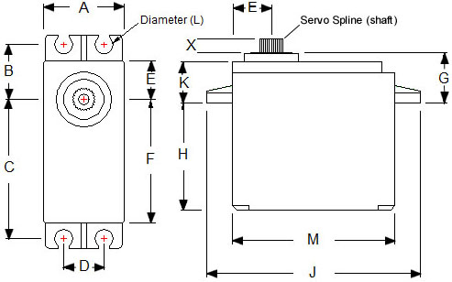

**A** = .780” (19.82mm)  
**B** = .530” (13.47mm)  
**C** = 1.33” (33.79mm)  
**D** = .400” (10.17mm)  
**E** = .380” (9.66mm)  
**F** = 1.19” (30.22mm)  
**G** = .460” (11.68mm)  
**H** = 1.05” (26.67mm)  
**J** = 2.08” (52.84mm)  
**K** = .368” (9.35mm)  
**L** = .172” (4.38mm)  
**M** = 1.57” (39.88mm)  
**X** = .120” (

C1 Hitec Spline2

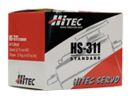

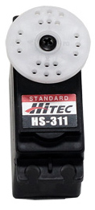

[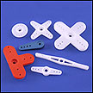](http://www.servocity.com/html/servo_arms___horns.html)

**Hitec Servo Splines**

At this time, Hitec manufactures servos with 5 different splines. When choosing components to attach to your servo, it is important to know what size of spline your servo uses. Below are the five various splines. If you have any questions as to what spline your servo has, please check the servo page or contact us via [email](mailto:sales@servocity.com) or phone (620-221-0123).   
(Splines below are not shown to scale)

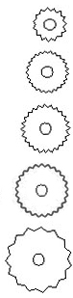

**A1 Sub-micro Spline (15 teeth)**  
HS-50, HS-55

**B1 Mini Spline (25 teeth)**  
HS-125MG, HS-56HB, HS-65HB.....many other mini servos

**C1 Standard Spline (24 teeth)**  
Any standard size Hitec servo. Even the HS-755HB, HS-755MG, HS-765HB and the HS-785HB servo use this standard size spline

**H25T *NEW!* Hitec Standard Spline (25 teeth)**  
HS-83XXTH and HSB-93XXTH series servos.  
**NOTE:** This spline is the same as the [Futaba 25T](http://www.servocity.com/html/futaba_servo_splines.html) Standard Spline (3F).

**D1 Heavy Duty Spline (15 teeth)**  
HS-805BB and HS-815BB servos

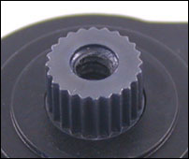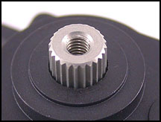

Metal Servo Spline Karbonite Servo Spline